* In Ansible the unit of work is module.
* Let’s try to use Ansible to install apache server on Ubuntu
  + Identify and execute the manual steps in configuring the apache server
* sudo apt update
* sudo apt install apache2 -y
  + Let’s Execute these steps to verify if they are working
  + Ansible Steps:
    - Try to identify and create/edit inventory
    - Searching modules in Ansible
      * Simple Approach: Google <cmd> in Ansible 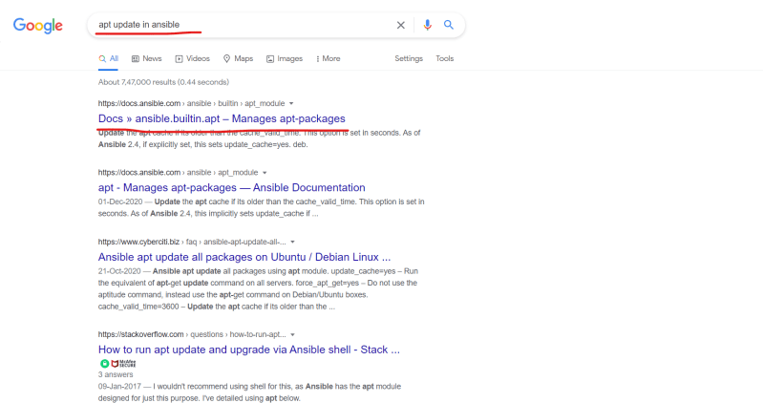
      * Any module in Ansible will have a state parameter

Playbook written in class

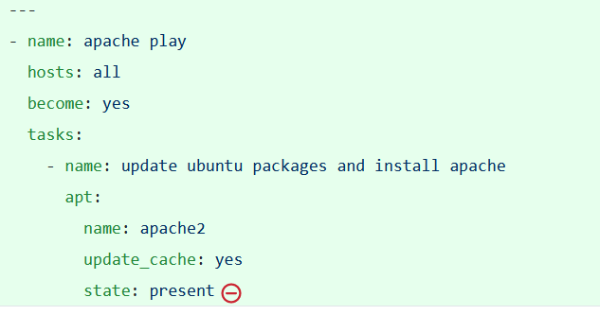

Link: https://docs.ansible.com/ansible/latest/user_guide/playbooks_intro.html#playbook-syntax

Usage of Ansible Playbook 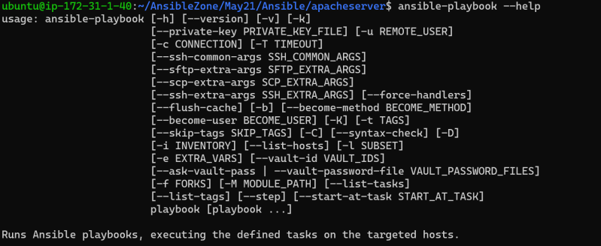

* + - To make this execution successful we need to provide inventory, playbook and private key

ansible-playbook -i hosts --private-key /home/ubuntu/ansible.pem apache.yaml

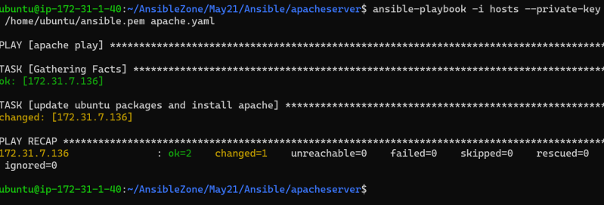

* Lets try to make our ansible lab setup more like an enterprise setup 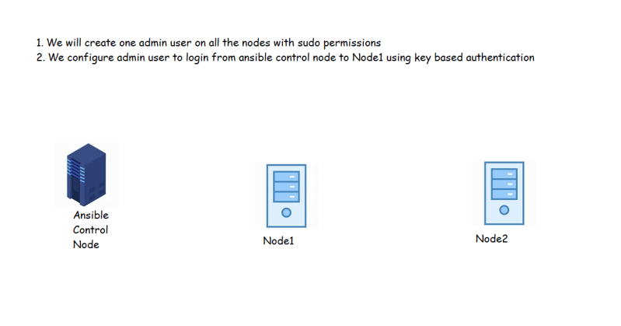
* Things to explore before doing this
  + visudo
  + ssh-keygen
  + ssh configuration in /etc/ssh/sshd_config
  + enable/disable password based authentication in linux